Information Pack for Educators
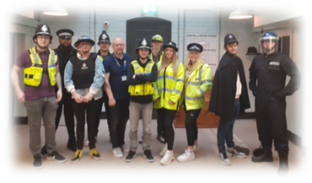
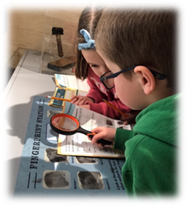
Everything you need to know for a class or group visit to The West Midlands Police Museum

Contents
Item | Page
Our History | 2
Find and contact us | 3
Booking a visit | 4
Booking and cancellation guidance | 5
While you are here | 6
Safeguarding and risk assessment | 8
Appendix A: Example visit itinerary | 10
Appendix B: Photo walkthrough for SEND learners | 11

Our History
Our police museum began as an idea of Detective Sergeant Charlie Elworthy. As part of Birmingham City Police’s training school, he wanted a collection of objects to help tell the story of policing in Birmingham. His enthusiasm spread throughout the force, and he built up a large collection.
The museum moved to Sparkhill Police Station in the 1990s, when PC Dave Cross took charge of it and built a successful education programme for schools. He also hosted open days and answered questions about people’s family history in policing.
In 2017, after the proposed sale of Sparkhill Station was announced, it was decided that museum would have a new permanent home at the Victorian Lock-Up at Birmingham Central Police Station in Steelhouse Lane.
Following a successful funding bid to the National Lottery Heritage Fund and the hard work of a huge team of architects, builders, movers and museum fitters, the West Midlands Police Museum opened in its new permanent home in April 2022, supported by colleagues in West Midlands Police, the PCC for West Midlands and our patron, Professor Carl Chinn MBE.

Find and contact us
The museum is located at The Lock-Up, 40 Steelhouse Lane, Birmingham B4 6BJ
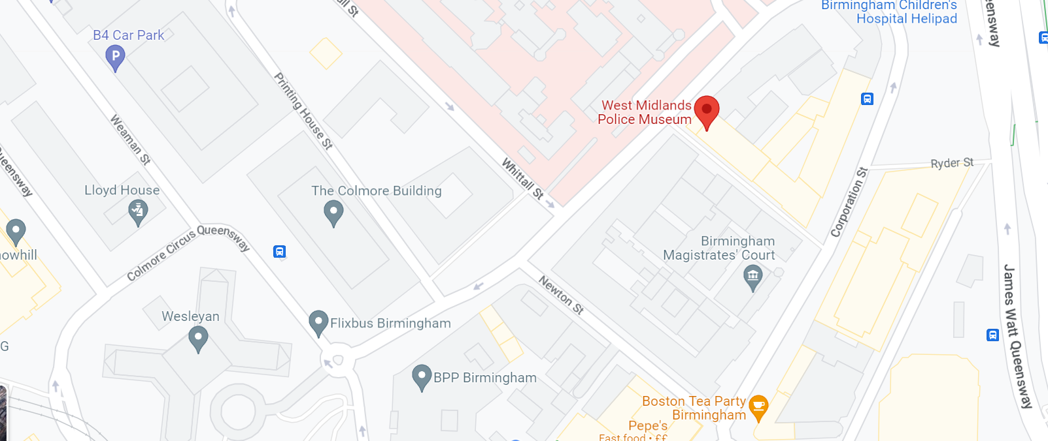

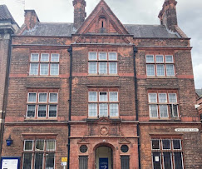
Located in the heart of Birmingham city centre, it’s easy to reach West Midlands Police Museum. The city has a great transport system so getting here is simple, however you want to travel.
Train: The museum is a very short walk from Birmingham Snow Hill Station and just 10 minutes’ walk from Birmingham New Street and Moor Street stations.
Bus or Metro: Most bus services stop within walking distance of the museum and the nearest metro stop is on Bull Street which is a five-minute walk away.
Driving: The nearest car park is on Weaman Street and there’s also Birmingham Royal Angus NCP car park nearby. Coaches can drop off and pick up on Steelhouse Lane, outside the main entrance and learners can safely gather in Coleridge Passage, a pedestrian walkway. Birmingham city centre is a Clean Air Zone, which may incur charges.
Contact Us:
Our Engagement Officer Archie is contactable via email at tracy.arch@westmidlands.police.uk or telephone on 0777 555 3779.
Visit our website: https://museum.west-midlands.police.uk/
Call us on: 0121 609 1700
Booking a visit
Plan an exciting day out filled with policing history.
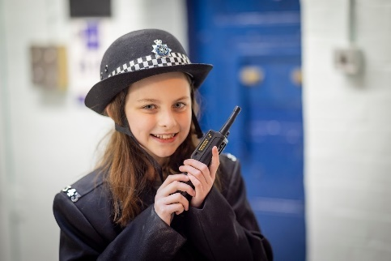
We offer days out for primary and secondary schools, further and higher education establishments and other education and learning based groups to come and discover what it was really like to spend time on both sides of the bars in our one of a kind police museum.
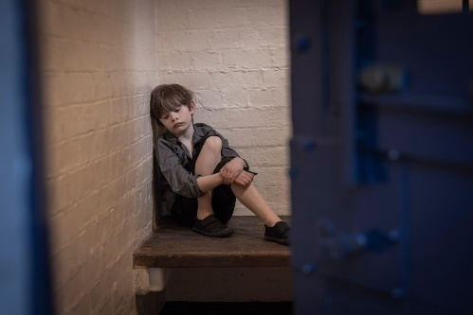
We will work with your staff prior to each visit to create a bespoke day out, with an input that meets your curriculum requirements, either about the history of crime and punishment or the modern-day messages of policing. Our experienced museum team will also give a tour filled with lots of activities for your students to take part in. They’ll be able to investigate and solve crimes in our forensics lab and find out fascinating facts while answering an age-appropriate quiz.
The museum can accommodate up to 45 learners on any day that we are open to the public and larger groups on Mondays or Tuesdays, when a comfortable maximum is about 90 learners. We can also accommodate up to 50 young people for an exciting, education based and unique sleepover (additional charges will apply, please ask for more details).
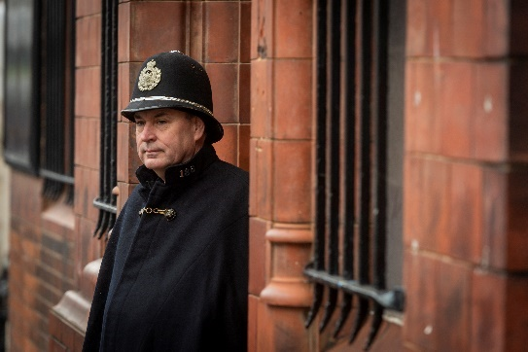
An educational visit usually runs from 10am to 2.30pm and will include a talk or interactive activity designed to meet your curriculum requirements. The visit costs £5.50 per learner for schools and £7 per learner for university groups (a minimum total cost may apply), with an appropriate number of supporting staff included for free.
Simply go to the Learn menu of our website, choose an available date on the interactive calendar and then complete the pop-up enquiry form to start planning your group’s adventure with West Midlands Police Museum.

Booking and cancellation guidance
Please note that The West Midlands Police Museum only accepts bookings from schools on the basis of the terms and conditions stated below:
- Bookings should be made by a representative of the school, acting on professional business only.
- The current cost of entry to the museum for a school group is £5.50 per child, or a minimum of £50.00, with an appropriate number of supporting staff included free of charge. (Please contact us in relation to the possibility of waiving the minimum cost).
- The current cost of entry to the museum for learners in higher education is £7 per person, or a minimum of £70.00.
- A non-refundable 10% deposit is required immediately on receipt of an invoice, in order to secure the date of any educational group booking.
- Schools who are able to liaise with the Museum Engagement Officer in advance of their visit will be able to participate in the development of a bespoke experience for their learners.
- Where possible, bookings should be made at least one term in advance and groups should await booking confirmation before making travel arrangements.
- The times and content of sessions may be subject to change at any time and without prior notice if necessary, for example for reasons of public safety.
- For groups attending on an organised visit with children, but not from a school (for example home-schooling groups) one adult is allowed to attend the museum, per child. Any additional visitors must pay the advertised cost.
- The balance of the cost of the visit should be paid in full no less than one week prior to the date of the visit. Payments by BACS transfer are preferable, although cash or card payments will be accepted with prior agreement from museum management.
- Staff from the visiting school or group are responsible for the behaviour management of their learners and abusive behaviour towards our staff and volunteers will not be tolerated.
- Any damage caused during a visit will result in an invoice for the cost of repair or replacement being issued to the trip organiser.
- Staff reserve the right to request that any members of a school party repeatedly behaving in such a way as to endanger themselves, other persons, or the museum collection be escorted from the premises.

While you are here
Important things to note before you visit:
The West Midlands Police Museum is located in an authentic Victorian holding facility and as such there is limited space. We do not have any outdoor space where learners can play.
We do not have catering facilities for educational groups. You are welcome to bring a packed lunch, but due to the restricted space in the building this may need to be eaten ‘picnic style’ using cushions on the floor in the basement. Visitors are requested to take their rubbish away with them wherever possible, as we have no facility for rubbish collection from the museum.
The museum is housed across all three floors of the building, so there is likely to be a lot of walking, and a lot of stairs, during the visit.
There are toilets in the basement. Both male and female facilities have two stalls only and these will also be used by members of staff and members of the public if you visit on a Wednesday, Thursday or Friday.
There is a shop on site and learners usually bring with them between £5 and £10. You can check out what is available in advance on the Shop menu of our website or pre-order from a selection of goody bags for each learner in advance at a cost of £5 each.
A bespoke visit itinerary will be provided for your group, prior to your visit. As we cannot guarantee how far in advance this will be completed, due to the bespoke nature of our provision, an example plan can be found in the appendix of this document. If there is anything that you are not happy with or need to changed, on receipt of the itinerary for your group’s visit, please contact the Engagement Officer, who will happily make the required changes.
We like to create a day that is packed full of fun and learning, as such we are unlikely to schedule a mid-morning break. If this is required please ensure that the Engagement Officer is aware in advance of your visit.

Accessibility information:
There are three steps at the main entrance of the museum. We have a level access entrance at the side of the building in Coleridge Passage. If you need to use this entrance, then please follow the signs to Coleridge Passage and intercom at the entrance there.

The reception area near the main entrance is fitted with an induction hearing loop.
The landings in the museum vary in width and are quite narrow at certain points. The narrowest part of the landing is 820mm at specific points where there are pipes running down the wall. Please be mindful of these restrictions when visiting using a wheelchair or pushchair as there is limited access. Unfortunately, mobility scooters cannot come into the museum due to the limited space
The nature of our historic cell-block means that over its three floors there are open metal grilles across all the landings and stairwells. We would advise against wearing high heels and would recommend that visitors avoid wearing skirts or dresses.
Cells are used for displays and their floors are not always level with the landing. The basement floor has a slight slope either side from the cells towards the centre of the floor.
There is an enclosed lift on one side of the building, with a maximum capacity of 400kg.
The museum has an accessible toilet which conforms to Part M (building regulations) design and which is located on the ground floor. This room also has baby changing facilities, but our nearest Changing Places Toilets are at Birmingham New Street station or Bull Ring Grand Central.
Assistance animals are welcome in the museum – water and bowls can be provided.
The museum has an interactive sound scape on the ground floor and noise travels easily around the building. We advise that learners who are affected by high noise levels bring ear defenders, as the museum can be noisy at times.
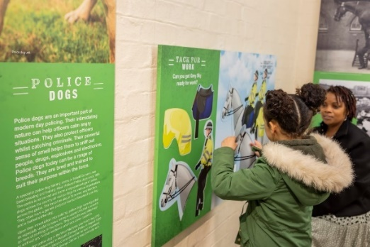
Large print versions of any worksheets can be provided – please request these in advance and inform the volunteer leading the appropriate group of any learners who require them.

Safeguarding
We make every effort to ensure that your group can learn and have fun in a safe environment, but please note that any visit for a group of 45 learners or less is likely to take place when the museum is open to the public. The small and enclosed nature of our premises means that all of your learners will be working with members of your staff and our staff and volunteers at all times during their visit.
Our Engagement Officer, Archie is a Level 5 DSL, qualified to work with both children and vulnerable adults and she and the rest of the team of six paid members of staff are regularly vetted at a high level by West Midlands Police. All volunteers working in any capacity at the museum have also undergone West Midlands Police vetting. Staff and volunteers all undergo mandatory safeguarding training and all wear distinctive uniforms, so your learners will be able to find help quickly if they need it.
Risk Assessment
Hazard |  | Existing Controls |  | Additional Controls
Access and egress – pushing/ overcrowding, pedestrians into the road etc. | Schools/groups arrange to come at a particular time and are let in straight away, in one go, through the level access in Coleridge Passage, thereby keeping the street outside the main entrance clear.
Slip, trip and fall hazards. | Regular health and safety walk throughs.  Walk round before events.  New, wide and clear staircases.  All communal areas/walkways are kept clear.  Spillages are cleared as and when located. |  | All staff and volunteers understand the need for awareness around hazards and the requirement to clear up any litter or spills immediately.
Fire Risk. | Weekly fire alarm tests.  Fire risk assessment complete.  Premises include automatic fire detection system, emergency lighting, firefighting equipment, alternative means of escape, escape signage, staff strategically positioned to facilitate evacuation of public if needed. |  | All staff are fully fire marshal trained.  All volunteers have undergone fire awareness training.  Good housekeeping to maintain low amounts of flammable, combustible or accelerant material on site.
Overcrowding | Maximum number of children 90 (with sufficient adults and volunteers for groups of 15-20).  Larger groups will be split and offered a carousel of activities, in order to avoid overcrowding in any area. |  | Any very large school groups to be accommodated on days when the museum is closed to the public.
Custody doors slamming on fingers | Doors are locked open to ensure they cannot lock when visitors are in a cell.  Staff are on every level and monitor the public as they tour so are able to intervene if necessary  Children advised upon arrival during a health and safety briefing. |  | Checks of cell doors are made prior to group visits.
Lack of relevant trained people | All paid staff members are trained as fire marshals and in first aid and use of an evac chair.  All volunteers receive site H&S induction and are taken through museum operating arrangements.  H&S briefing before every event.  First aid room identified.  First aid kids checked and monitored. |  | Accident forms to be completed as and when required.
Poor lighting or heating | The building has new systems of heating and lighting.  Promptly report any lighting or heating failures through the portal for remedial action to be arranged. |  | Prior to remedial action, where areas of the lock up are in darkness staff to assess and take a decision to cordon off an area if necessary.
Deficient welfare facilities | Toilets and washbasins provided.  2 sanitary bins in ladies’ toilets.  Accessible toilet facilities including a nappy changing station and disposal bin. |  | An adequate cleaning regimen has been arranged with facilities management, with a cleaner allocated to clean the museum and toilets.  Regular checks will ensure soap and facility for drying hands (and sanitary disposal) is always readily available  Arrangements are in place to dispose of clinical waste when required.
Poorly maintained educational equipment. | All equipment for use by schools’ groups is well maintained and kept tidy. |  | Everything is locked in cells or in lockers when not in use, for safety and to prevent damage.

Appendix A: An Example Visit Plan
Example Primary School
Visit Date  60 students – Year 6  Requested focus:  Crime and Punishment | Volunteer 1  Volunteer 2  Volunteer 3  Volunteer 4 | Group A  Group B  Group C  Group D
10:00 School arrives
Welcomes; housekeeping; organisation etc.
Split into 4 groups and allocate a volunteer to each (as above).
Coats and bags can be stored in the basement.
10:30 Session 1
- Begin tour on top floor.
- Begin tour on ground floor.
- Basement area activities.
Talk in the Education Space.
11:15 Session 2
- Continue tour on ground floor.
- Continue tour on top floor.
- Talk in the Education Space.
- Basement area activities.
12:00 Lunch Break
Use chairs and 2 x donut packs in basement area.
(Visitors are requested to take rubbish away with them)
All volunteers to take a break also.
12:30 Session 3
- Basement area activities.
- Crime and Punishment Talk.
- Begin tour on ground floor.
Begin tour on top floor.
1:15 Session 4
- Crime and Punishment Talk.
- Basement area activities.
- Continue tour on top floor.
- Continue tour on ground floor.
2:00 Return to basement.
Feedback etc.
Opportunity to visit the museum shop.
2:30 School leaves
Note: Basement activities.
Aim for 3 x 15 minutes.
- volunteers will be available per session, while Archie leads the input.
Handling Collection (Groups A & B V1/Groups C & D V3); Forensic trail (Groups A & B Vol 2/Groups C & D Vol 4); Dressing Up (School staff).

Appendix B: Photo Walkthrough
You are coming to visit the West Midlands Police Museum at the Lock-Up.
This is some of what you will see and hear.
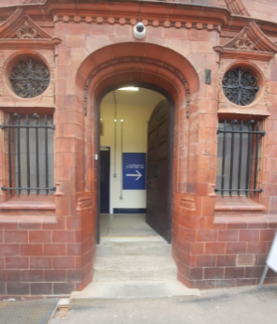
The Entrance
There is a big door and two steps up to the museum entrance.
The road is quite busy, be careful and listen to your teachers.

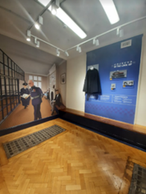
The Introductory Area
The floor here is wooden, but there are some glass panels that look down.
There is a special piece of art that makes the room look bigger, but it is only a drawing.
There are metal gates, but they are open, so no one can get trapped.

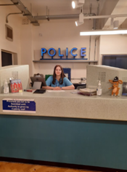
The Charge Desk
The desk is very high. Someone is always working here.
Next to the desk is a really big lamp.

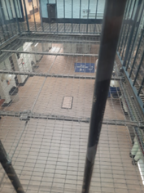

The Building
There are three floors and you can see all the way from the basement to the roof. It can get quite loud because there are no ceilings to stop the noise.

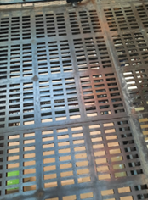

The Floor
The walkways are metal with holes. They can be a bit odd to walk on and they make a lot of noise if people stamp around.

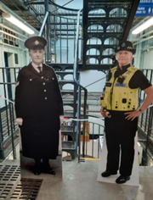
The Female Officers
These two ladies can be a bit scary if you don’t know they are there.
They are only cardboard cut-outs and nothing to worry about.

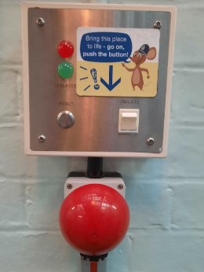
The Soundscapes
There are three buttons like this with a picture of Lock-Up Mouse.
If someone presses them they make a noise.
The noises are Cookie, the lock-up cat; lots of prisoners shouting and banging and a police officer walking and jangling keys.

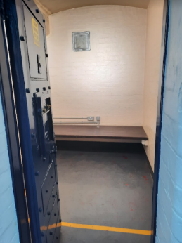
The Cells
There are lots of cells at the lock-up. They are quite small.
Some have information or other things inside.
The doors cannot be locked, so no one can be trapped.
If you don’t like how small they are, you do not have to go inside.

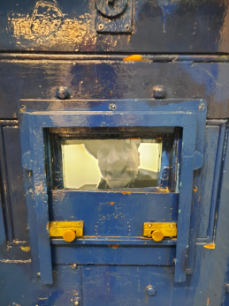

Tommy Tank
You can hear a man shouting and telling stories from one of the cells.
His name is Tommy.
This is a film, there is not really a person inside.

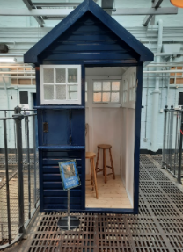
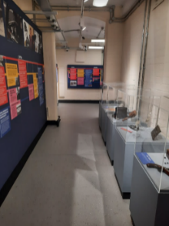
The Top Floor
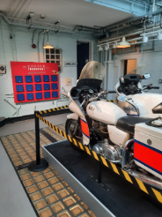
Here there is a long room that tells you all about the history of our police force.
We also have a big blue police box and there are some police motorbikes.

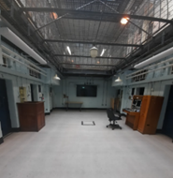
The Basement
Here, there is a big space where schools can do lessons and eat a packed lunch.
Be careful, the floor slopes a bit, into the middle.
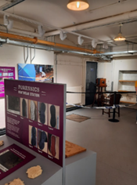

The Forensics Area
Here we have a big science area with puzzles to solve.

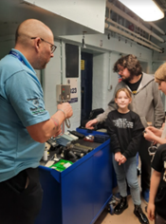
The Volunteers
Our volunteers can show you some of the museum collection.
They might give you a tour of the museum or help with the forensic trail too.

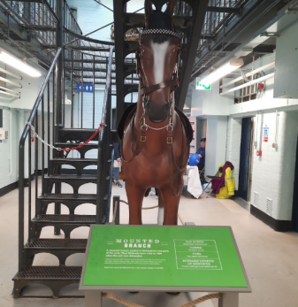
The Horse
This is our huge horse! He is as big as a real horse.
We call him Charlie.
He cannot move, he is just a model.

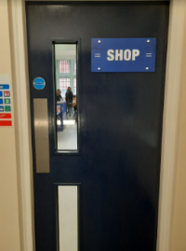
The Shop and Exit
Before you go back to school, you might be able to go to the shop.
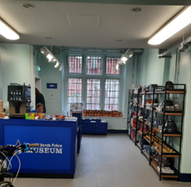
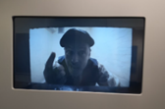
There is a film there and Tommy Tank sometimes talks. It can make you jump, but it is nothing to be scared of.

